

Git and GitHub – Individual

Data Analytics and Artificial Intelligence Tools 2 (Gpo 101)

Names and IDs:

Humberto Gonzalez Escamilla - A00837328

November 20, 2025
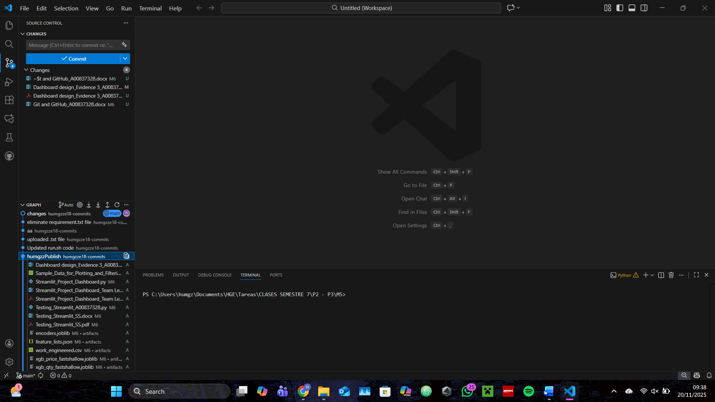
Screenshot of my GitHub on VSCode Working

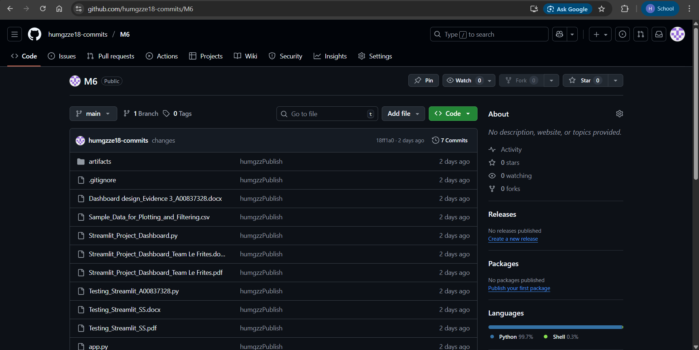
Screenshot of my GitHub Repository and the link to access it.

Link: https://github.com/humgzze18-commits/M6

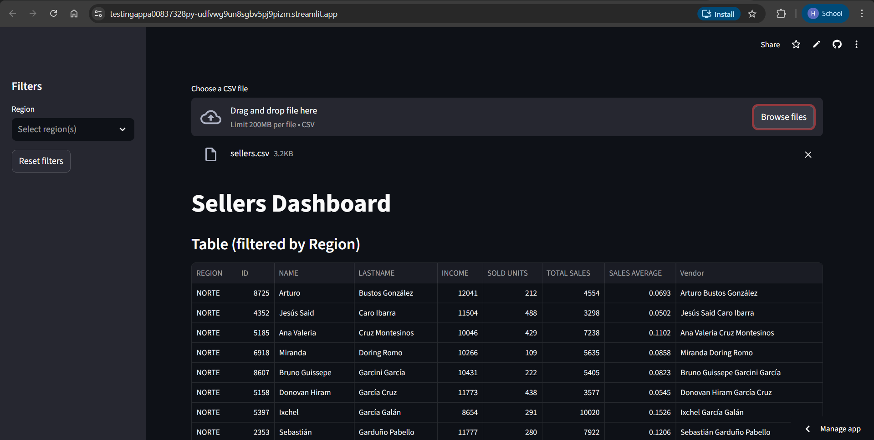
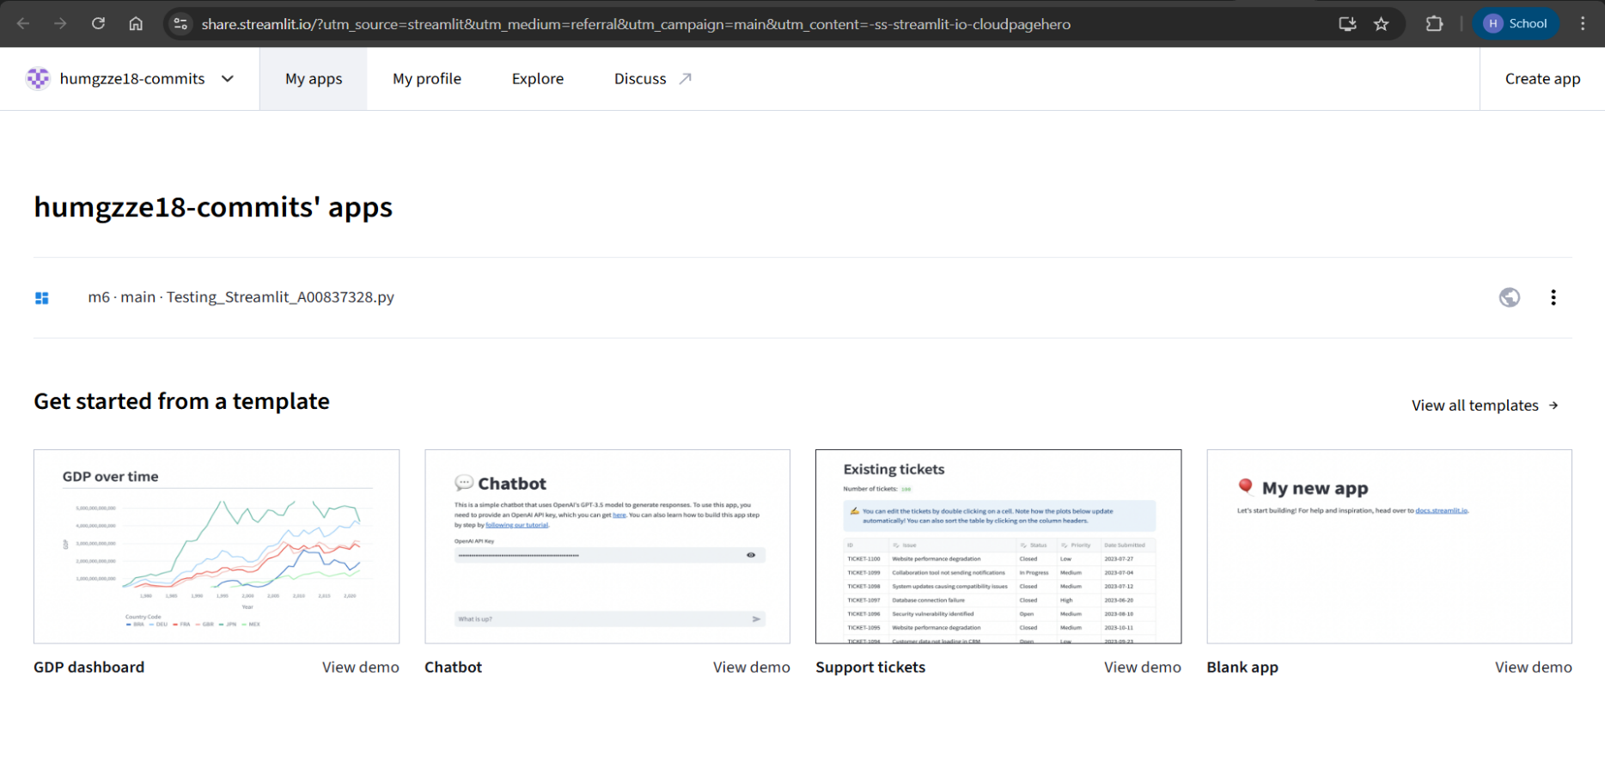
Screenshot of my app deployed and the link to access it.
Link: https://testingappa00837328py-udfvwg9un8sgbv5pj9pizm.streamlit.app/

